**Does Weather impact Food sales?**

**Results:**

All the techniques are properly measured to assess climate and atmosphere extremes in atmosphere display recreations. The mix of atmosphere model with observational and reanalysis items requires creative examinations and measurements of execution that make utilization of data identified with procedures producing inside atmosphere changeability and opening up climate and atmosphere extremes.

The results from the below methods shows the correlation between every variables and its sizeable impact on the food sales. The key variables identified by performing various techniques and the graphs below identifies the correlation between them.

**Linear Regression:**

Simple straight relapse is a factual method that permits us to summarize and ponder connections between two consistent (quantitative) factors: One variable, denoted x, is viewed as the indicator, illustrative, or free factor. The other variable, denoted y, is viewed as the reaction, outcome, or ward variable.

Since alternate terms are utilized less every now and again today, we'll utilize the "indicator" and "reaction" terms to allude to the factors experienced in this course. Alternate terms are mentioned just to make you mindful of them should you experience them in different fields. Simple direct relapse gets its descriptor "simple," since it concerns the investigation of just a single indicator variable. Interestingly, multiple direct relapse, which we concentrate later in this course, gets its descriptor "multiple," on the grounds that it concerns the investigation of two or more indicator factors.Before continuing, we must elucidate what sorts of connections we won't think about in this course, namely, deterministic (or practical) connections. Here are some examples of other deterministic connections that understudies from past semesters have shared. For each of these deterministic connections, the condition precisely depicts the relationship between the two factors. This course does not examine deterministic connections. Rather, we are occupied with measurable connections, in which the relationship between the factors is not great.

Here is an example of a measurable relationship. The reaction variable y is the mortality because of skin growth (number of passings per 10 million individuals) and the indicator variable x is the scope (degrees North) at the focal point of each of 49 states in the U.S. (skincancer.txt) (The information were compiled in the 1950s, so Alaska and Hawaii were not yet states. What's more, Washington, D.C. is incorporated into the informational index despite the fact that it is not actually a state.) skin malignancy versus state scope plot. You might envision that in the event that you lived in the higher scopes of the northern U.S., the less presented you'd be to the harmful beams of the sun, and in this manner, the less hazard you'd have of death because of skin tumor. The scramble plot backings such a theory. There gives off an impression of being a negative direct relationship amongst scope and mortality because of skin tumor, however the relationship is not great. To be sure, the plot displays some "pattern," yet it likewise shows some "diffuse." Therefore, it is a factual relationship, not a deterministic one.

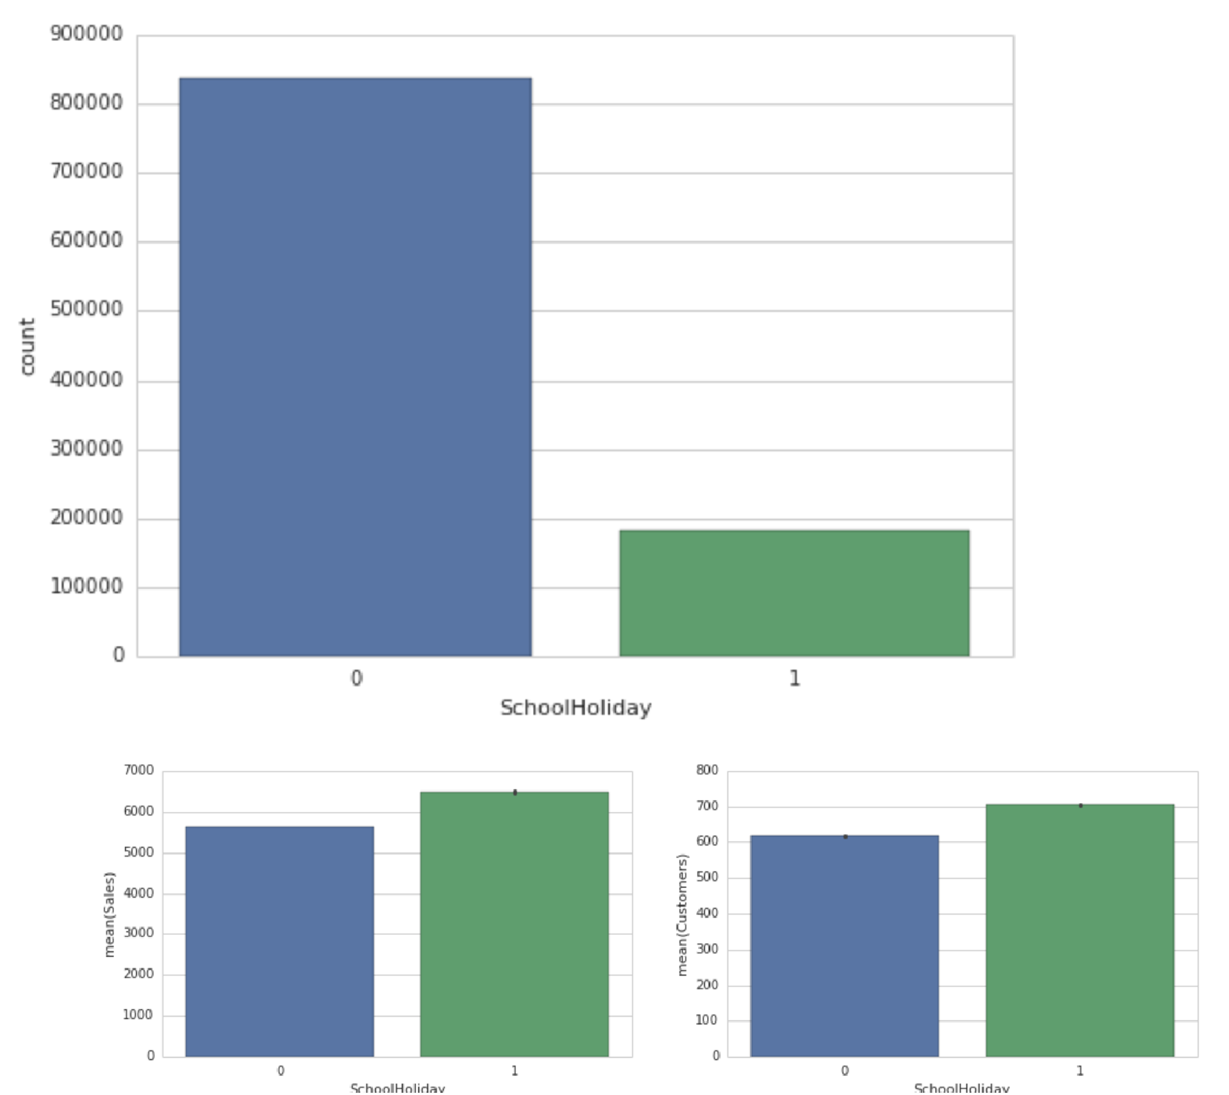

The graph indicated the co relation between school holidays and the food sales.

**Service Vector Machine:**

Bolster Vector Machine" (SVM) is an administered machine learning algorithm which can be utilized for both characterization / relapse challenges. Be that as it may, it is mostly utilized as a part of order problems. In this algorithm, we plot every information item as a point in n-dimensional space (where n is number of components you have) with the estimation of each element being the estimation of a specific organize. At that point, we perform characterization by finding the hyper-plane that separate the two classes extremely well. Support Vectors are simply the co-ordinates of individual observation. Support Vector Machine is a frontier which best segregates the two classes (hyper-plane/ line). We got accustomed to the process of segregating the two classes with a hyper-plane. Don’t worry, it’s not as hard as you think!

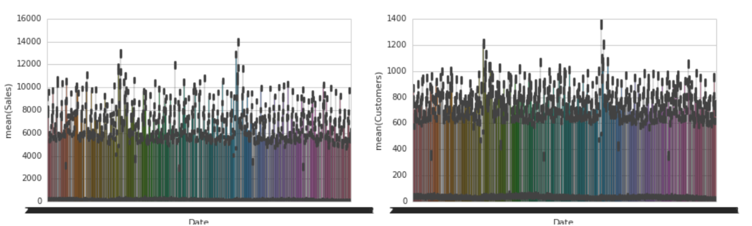

**Pros:**

It works truly well with clear margin of division

It is powerful in high dimensional spaces.

It is powerful in situations where number of dimensions is more prominent than the number of samples.

It utilizes a subset of preparing focuses in the choice capacity (called bolster vectors), so it is likewise memory productive.

**Cons:**

It doesn't perform well, when we have substantial informational collection in light of the fact that the required preparing time is higher

It likewise doesn't perform exceptionally well, when the informational index has more commotion i.e. target classes are covering.

SVM doesn't specifically give likelihood estimates, these are figured utilizing a costly five-overlay cross-approval. It is connected SVC method of Python scikit-learn library.

**Random Forest:**

Random forests or random decision forests are an ensemble learning method for classification, regression and other tasks, that operate by constructing a multitude of decision trees at training time and outputting the class that is the mode of the classes (classification) or mean prediction (regression) of the individual trees. Random decision forests correct for decision trees' habit of overfitting to their training set. The first algorithm for random decision forests was created by Tin Kam Ho using the random subspace method, which, in Ho's formulation, is a way to implement the "stochastic discrimination" approach to classification proposed by Eugene Kleinberg. An extension of the algorithm was developed by Leo Breiman and Adele Cutler, and "Random Forests" is their trademark.The extension combines Breiman's "bagging" idea and random selection of features, introduced first by Ho and later independently by Amit and Geman in order to construct a collection of decision trees with controlled variance.

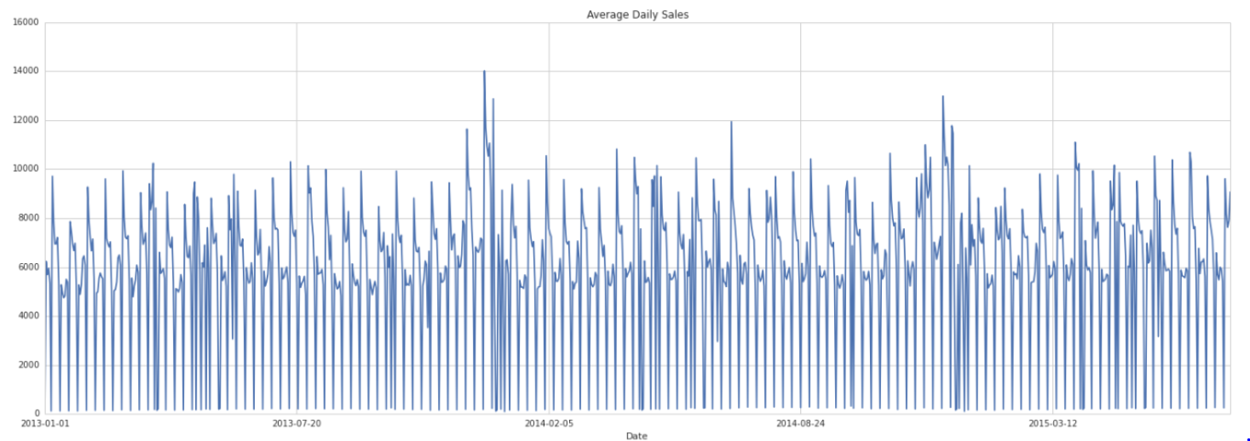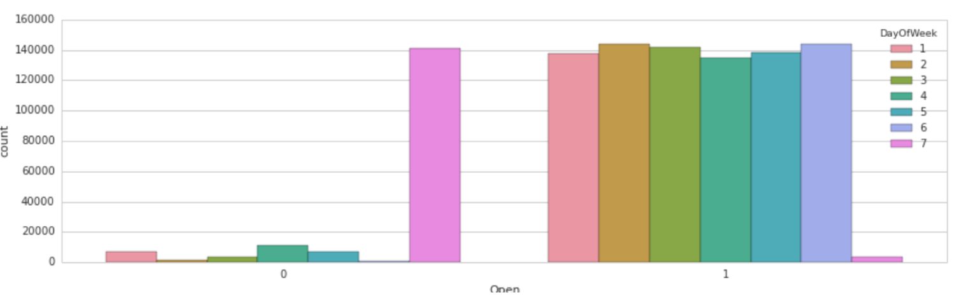

**Components of Random Forests:**

It is unexcelled in precision among current algorithms.

It runs productively on huge information bases.

It can deal with a large number of information factors without variable cancellation.

It gives estimates of what factors are important in the order.

It creates an interior fair-minded estimate of the speculation blunder as the woodland building advances.

It computes proximities between sets of cases that can be utilized as a part of bunching, finding exceptions, or (by scaling) give intriguing perspectives of the information.